**EDUCATIONAL WEBSITE**

END TERM PROJECT

***by***

**OMKAR RAUSHAN**

Section: K19TP

Roll Number: 66

**MUSKAAN**

Section: K19TP

Roll Number: 31

**SHAREEN SAINI**

Section: K19TP

Roll Number: 03



**Department of Intelligent Systems**

**School of Computer Science and Engineering**

**Lovely Professional University, Jalandhar**

April-2020

**Student Declaration**

This is to declare that this report has been written by us. No part of the report is copied from other sources have been duly acknowledged. We aver that if any part of the report is found to be copied, we shall take full responsibility for it.

Omkar Raushan

Roll Number: 66

Muskaan

Roll Number: 31

Shareen Saini

Roll Number: 03

Place: Phagwara

Date: April 11, 2020

**TABLE OF CONTENTS**

**TITLE PAGE NO.**

1. **Background and Objectives of project assigned 01** 
   1. **Introduction 01**
   2. **Concept 02**
   3. **Impact 03**
2. **Description of Project 04**
   1. **About Project**
   2. **Efforts**
   3. **Implementation**
   4. **Technologies**
   5. **SWOT Analysis**

**25.1 Strengths**

**25.2 Weaknesses**

**25.3 Opportunities**

**25.4 Threats**

BONAFIDE CERTIFICATE

Certified that this project report “**EDUCATIONAL WEBSITE**” is the bonafide work of “**OMKAR RAUSHAN, MUSKAAN** and **SHAREEN SAINI**” who carried out the project work under my supervision.

Signature of the Supervisor

Dr. Dhanpratap Singh

Academic Designation

ID of the Supervisor

Department of Supervisor

1. **Background and Objectives**

In the modern era, People have nothing without any knowledge. Everyone needs some type of guidance to choose right path in life. So, this is our responsibility to give some contribution towards individuals. We are also doing our duty on education system. Our project is on Education Website.

* 1. **Introduction**

In many foreign countries, Education system is developing extremely vast. Although now in India the condition of education is not poor because there are so many educational institutes are available. The concept we are providing is something new which is both online and offline school education. Obviously, this is alternative idea to spread the knowledge all over the world.

No doubt in the today’s world, there are huge competitions among students in the field of education but some people have to face a lots of troubles that is why, they are enable to take knowledge. For those pupils this platform is very useful.

Our website will provide each and every information to students which is helpful for all standards. Despite of it, we provide advanced knowledge and activities. Hence this is the sector which can improve student’s thinking.

The online booking to take admissions for different classes is also available because in this way service taker has not to face any kind of problem. The detailed overview will be discussed later.

While doing this project, we have focused on all the different aspects needed in this field. The different web pages will elaborate each and every information according to the today’s need.

* 1. **Concept**

This project is entirely based on the education providing concept. This is basically a private school which is giving knowledge for each class and gives facility to establish the talent.

This concept is very similar to those of online classes which provide a variety of knowledge at different price ranges. The different webpages will depict the different images about the school which help the user to create the transparent relation of trust between them.

There are number of web pages in this website starting from index to last page which will be the contact information page.

These pages will include different types of activities and different packages for classes.

The website will provide all these services after the index which is helpful for user to take information about all the activities.

The designing of this whole website is done by using HTML and CSS and is tried and focused to keep it as simple as possible to make its use easy for everyone.

* 1. **Impact**

The involvement of online service providing platforms in education system has always a great impact. Actually these platforms provide some ease ways to understand. Instead of it, it is helpful for parents because via online classes they have no any anxiety of their children that they have to go outside to take extra classes. That’s why this will also have a wide range of impacts on our society.

The process of this project is so simple and has the capability to understand the education mode at different platform to improve the skills of students and can make them shine like a star.

1. **Description of Project**

The detailed overview and other descriptions are subdivided on various sub sects as discussed below:-

* 1. **About Project**

The project is on Kidzee website having six web pages.

The sequence of the website will be as

CONTACT

PRICING

GALLERY

PACKAGES

ABOUT EXPERTS

HOME PAGE

The above are the different steps the user has to go while using this website. There are only six and different steps to know moreover of this website. Furthermore, the modifications are done according to the requirements and needs of everyone so as to provide a smooth bond between clients and us.

This website is designed keeping all these needs, scopes and all other aspects. We will maintain the trust factor between both of the sides.

**2.2 Efforts**

This project is made by the collective effort of all of us leaded by Omkar Raushan. The coding, designing and layout formation is done by Omkar Raushan whereas the data, drafting and writing works are accomplished by Shareen Saini and Muskaan with the help of Omkar Raushan.

This website is a result of collective efforts. All the candidates also helped in giving its final touch.

* 1. **Implementation**

The website has different webpages each having some particular function as discussed above. These web pages are designed as per the data to be entered in that web page. This means the font, color, background, size all are according to the role of that particular web page in the websites.

We will discuss each of those web pages separately here so as to make the concept clear.

The code written is implemented as below:

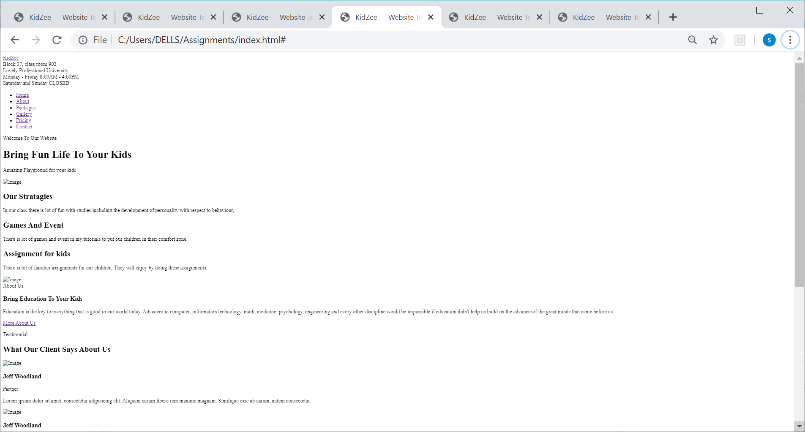

This is the home page “WELCOME TO KIDZEE WEBSITE”. At the top, the address of the Kidzee is mentioned.

Then the user has to check the venue of the school as well as timing of the classes which is the information is important for the students and parents. After that, in this page the closing days are also provided. Our tag line is “BRING FUN LIFE TO YOUR KIDS”.

After noted these information, user has to click on link ABOUT to proceed further to get more information. Then the new web page will be opened.

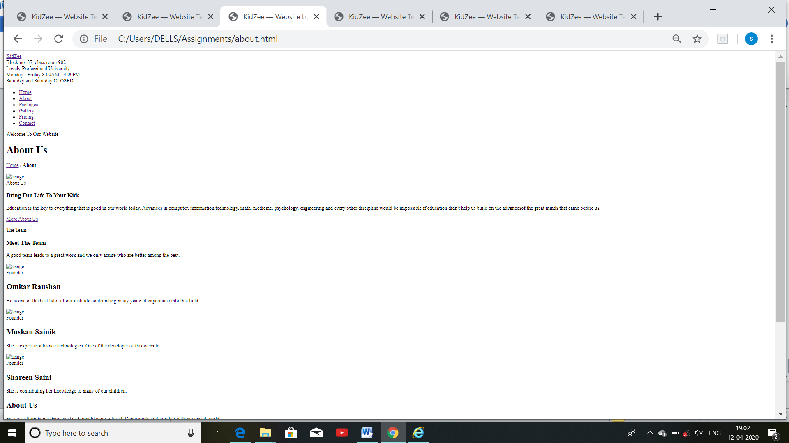

The second web page will be about the experts who provide their knowledge to students. There are three main experts who doing their job from many years.

The user can check the detail of each person that what they do for the children and what is the role of them in the KIDZEE.

As we said that there are three main experts, so firstly, who is the best tutor from many years is OMKAR RAUSHAN. Secondly, who give knowledge about advanced technology is MUSKAAN. After that, who contributing her knowledge to students is SHAREEN SAINI.

At last when the user saw these details then click on the link PACKAGES. So the next page will be opened.

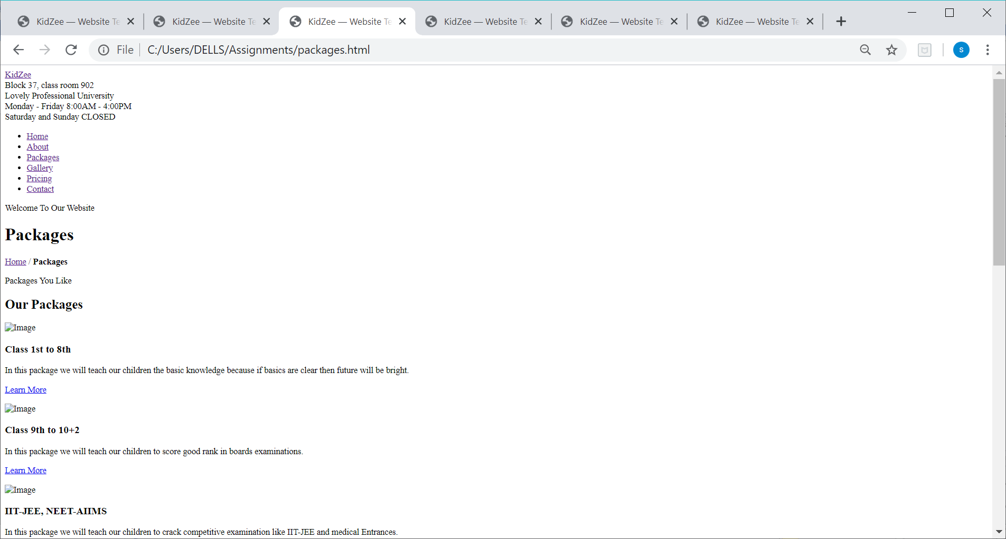

This will be our next page which is all about the different packages for different classes.

The users can choose the package according to their need. There are mainly three types of packages for the students.

The first package is for class 1st to 8th. Under this package teachers will teach the basic knowledge and more about the moral values.

The second package is for class 9th to 10+2. In this field, the experts will teach how to score good marks.

At last and third package is for IIT-JEE, NEET and AIIMS. In this section teachers will prepare their pupils for competitive exams.

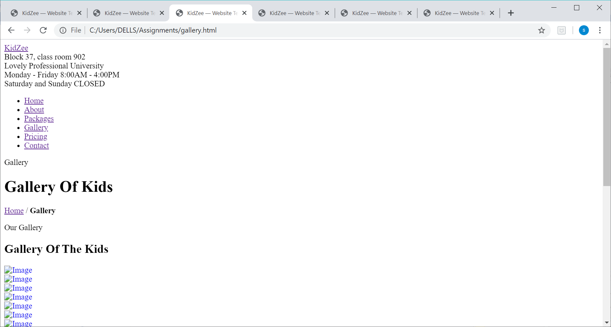

This will be our next page which requires only the images of the activities played by the kids

We have given the name of this web page is GALLERY OF KIDS. This is all about the curriculum activities and different assignments.

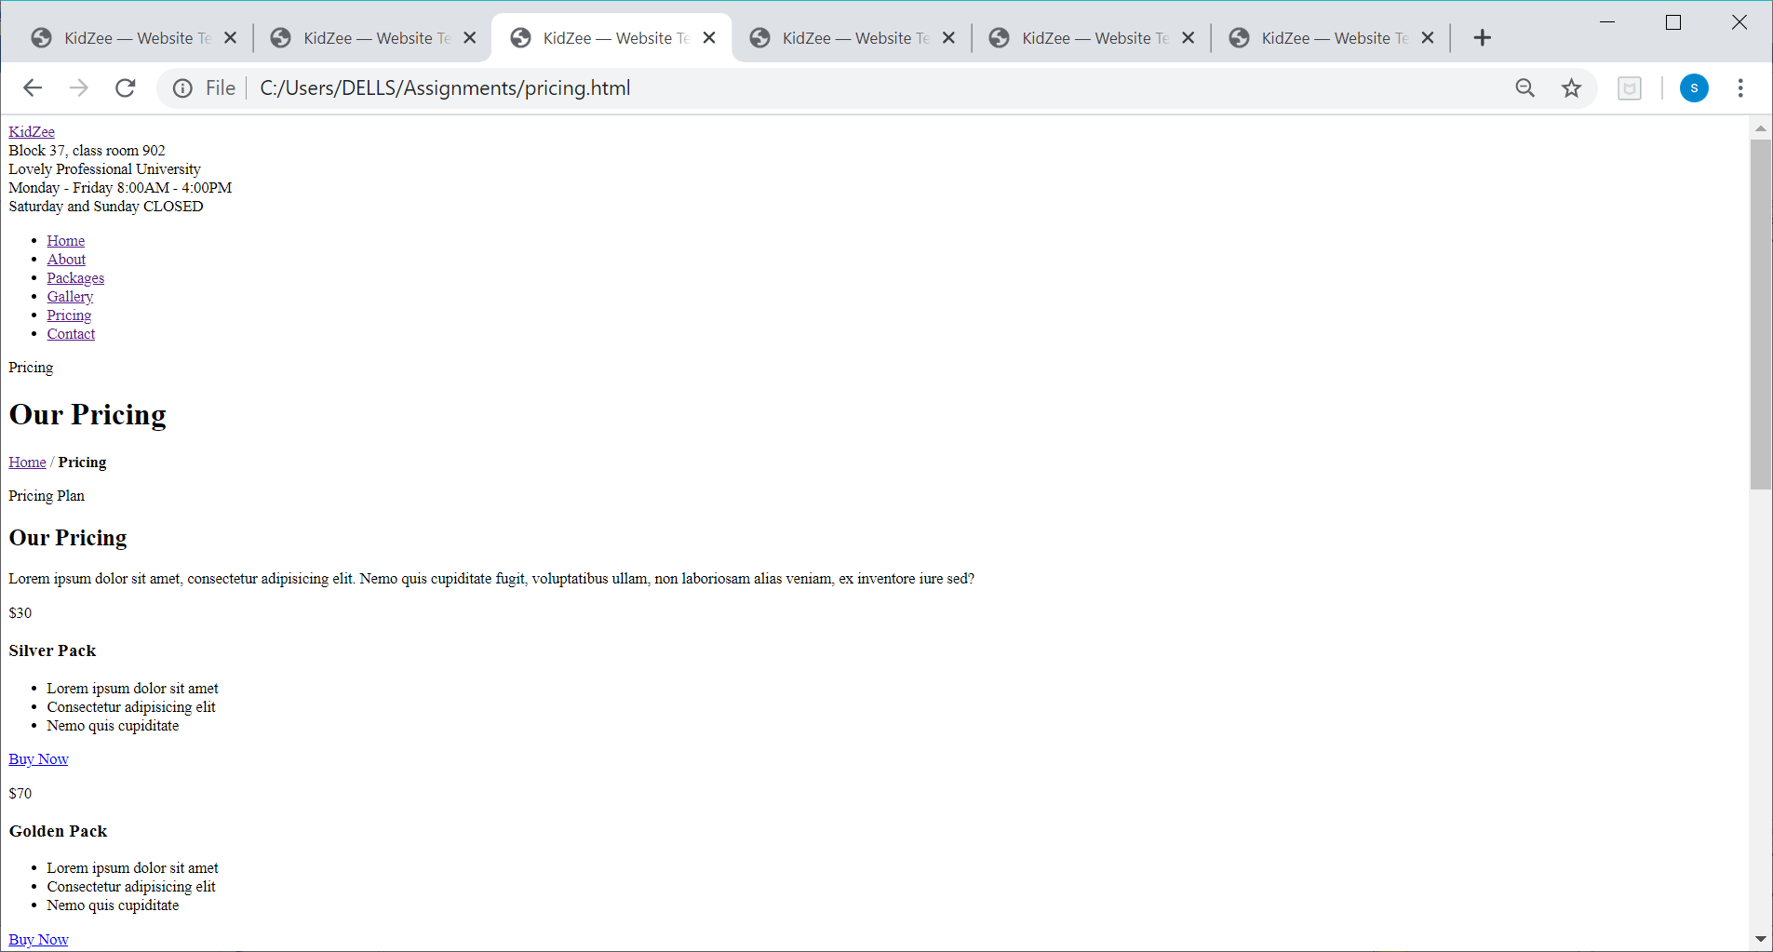

This is fifth web page. There are other two precious packs for children. The user can check the details of these packs which is Silver Pack and Golden Pack. In these facilities the user can take more benefits.

There are two different prices for per pack. For Silver pack it is $30 and for Golden is $70.

At the bottom of the per pack, there is link for buy it so, people can click on it to buy.

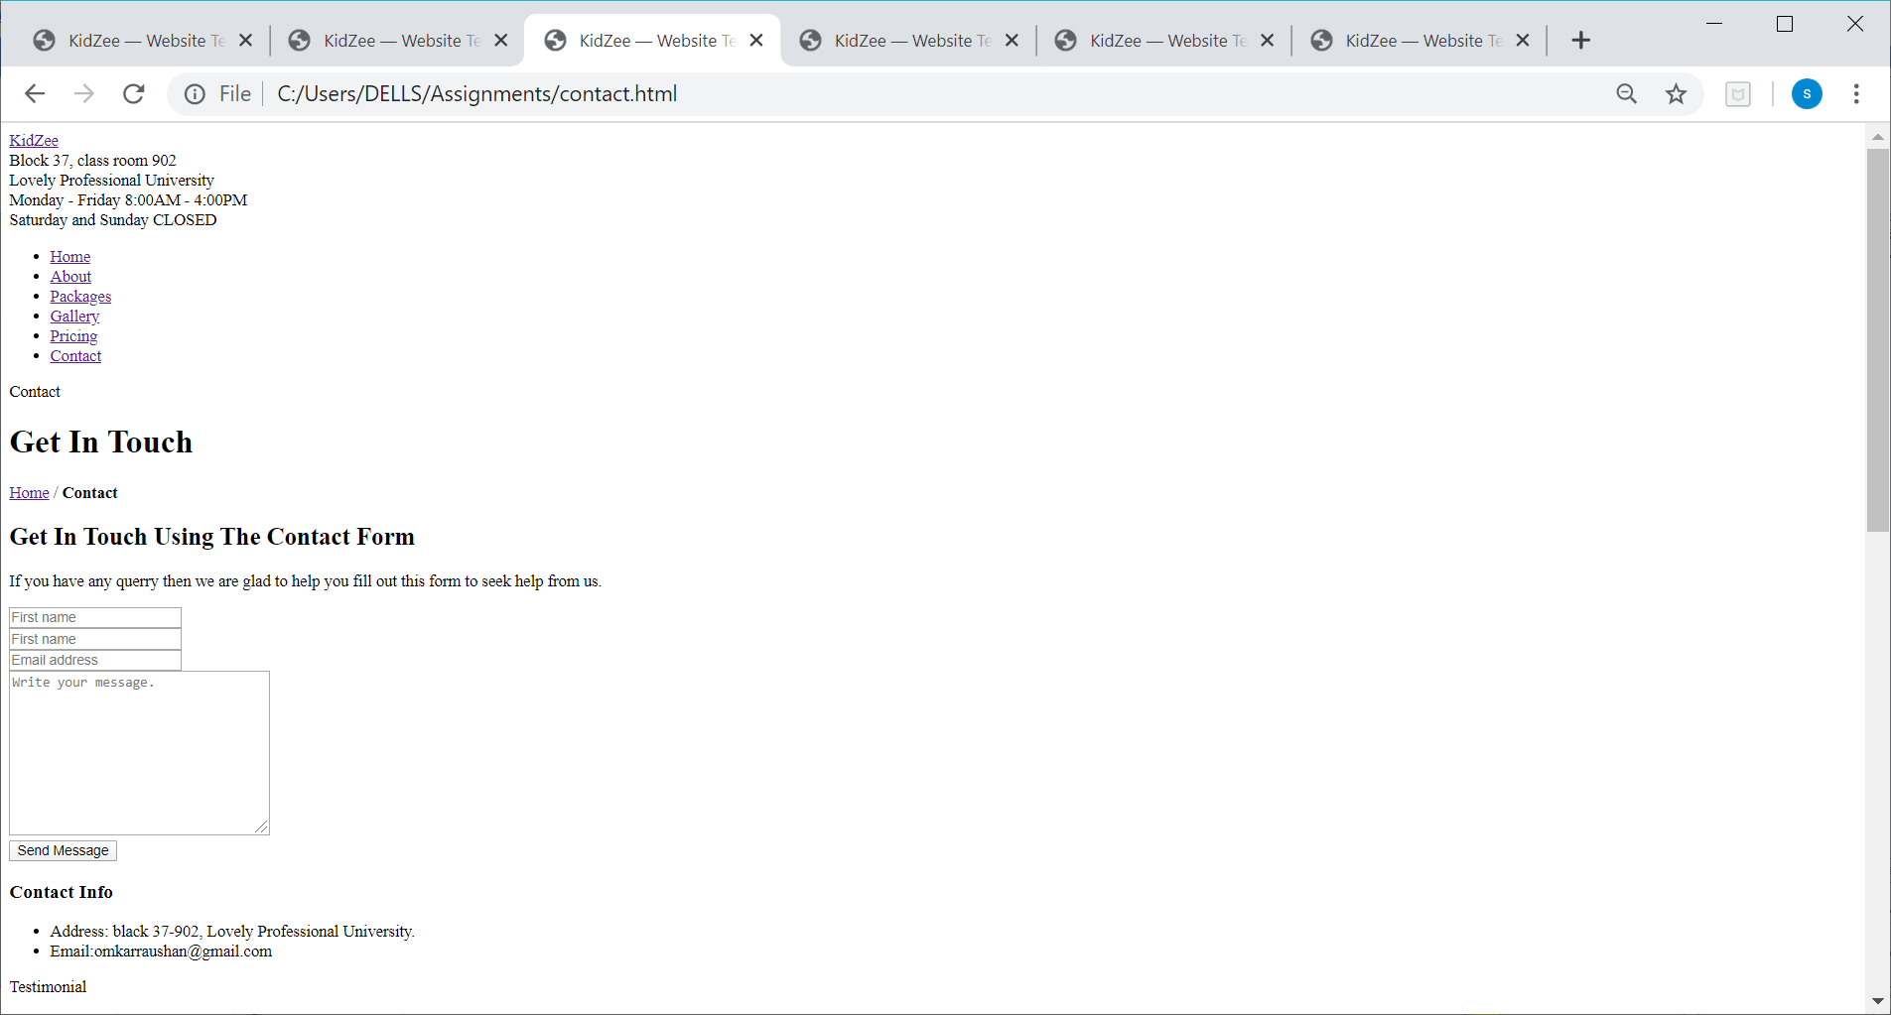

This is the very last page of this website which is most important to get in touch with us.

In this page, the contact information is provided to user. If user has any query then he/she can write their message in given box.

There are three different boxes for First Name, Last name and Email Address. After these options there is big box for write your message in it.

The user can send the message via given column below the message box.

In this webpage, we also provided our contact information. The user can receive any detail if they have any query through Email ID and they can also reach at the institution. For this, the venue of the center is also mentioned.

In this way the user can stay in touch with this website to receive any changes in the system or other information.

* 1. **Technologies**

The methods used for developing the websites are HTML and CSS only. We have applied the basic concepts of these two programming languages for the development of this site.

* 1. **SWOT Analysis**

The meaning of SWOT is S stands for Strengths, W for Weaknesses, O for Opportunities and T for Threats. We will discuss each of these in details:

**25.1 Strengths**

The main strength of this project easy understanding, simple structure, easy to access and its focus on something which is really needs to our today’s world.

**25.2 Weaknesses**

The foremost concern for the project is to find something new about students which is useful and helpful for them it’s quite difficult. Moreover, how to make a bond with clients and how to do attract them towards this website.

**25.3 Opportunities**

Currently, Education system is developing day by day. There are many platforms to get knowledge so, it has a huge range of scopes like students can improve their skills by some activities, they can show their talent at different levels, they can overcome their worries and so on.

**25.5 Threats**

It has various positive points and several chances, but it has some serious threats in society that other will create new ways to teach the students in this way people can attract more towards it. Which will reduce the opportunities of other institutions.